Technology and Innovation Workshop

Question no. 1
Aim:
Create a 3-page professional document in Word for a college event titled “Technology and Innovation Workshop.” The document should have a title section containing the event name, date, venue, and organizer details, followed by an automatic Table of Contents. The document should contain three main sections: About the Event, Event Schedule, and Registration Details. Each main section should start on a new page and use Heading 1. Sub-sections should use Heading 2. The Event Schedule should contain a 4-column table with at least 5 rows. Insert one relevant image and use text wrapping. Add a header containing the event name and a footer containing centered page numbers. The document should use consistent formatting throughout.

Objective:
To create a professional document for a Technology and Innovation Workshop using Microsoft Word with proper formatting, tables, images, header, footer and page numbers.

Hardware Requirements
- Computer / Laptop
- Minimum 4 GB RAM
- Keyboard and Mouse

Software Requirements
- Operating System: Windows / Linux / macOS
- Microsoft Word (Microsoft Office)

Procedure
- Open Microsoft Word
Open Microsoft Word and created a new blank document.
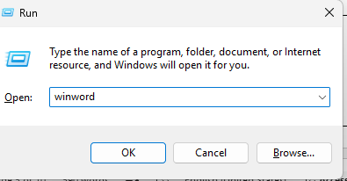

- Create Title Page

Created a title page with the event name, date, venue and organizer details.

- Add Event Information
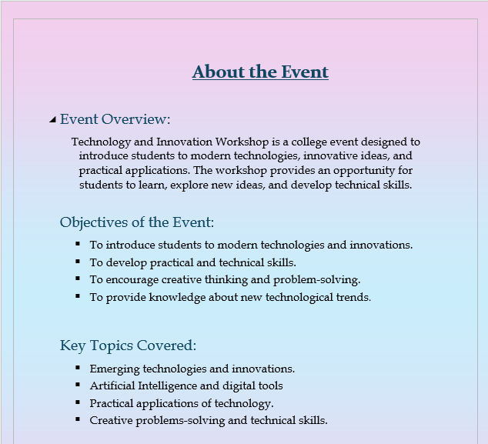
Added About the Event, Event Overview, Objectives and Key Topics Covered.

- Insert Image and Apply Text Wrapping
Inserting a relevant image in the event section and applied text wrapping.


- Created Event Schedule
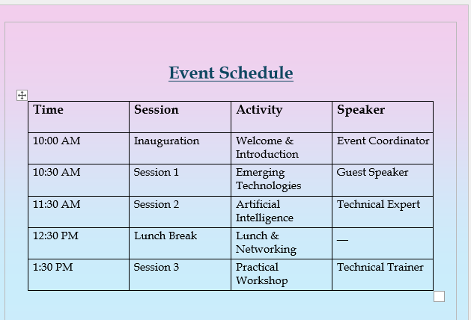
Created a 4-column table containing the event schedule.

- Add Registration Details
Added Registration Process, Eligibility, Registration Fee and Contact Information.

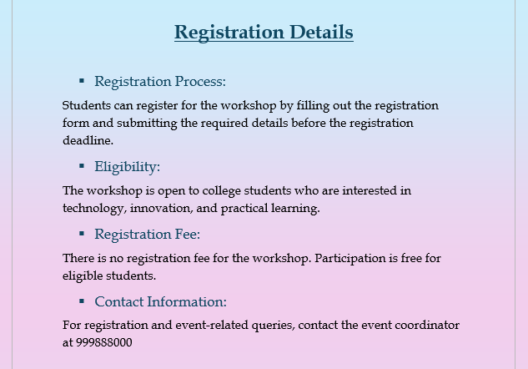
- Add Header, Footer and Page Number


Added a header and footer to the document.

- Created Table of Content
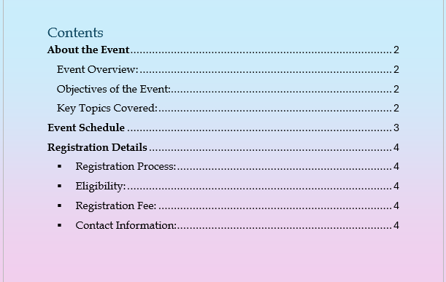
Applied heading styles and inserted an automatic Table of Contents.

- Save the Document
Saved the completed document in Microsoft Word format (docx).

- Result: The Technology and Innovation Workshop document was successfully created, formatted and saved using Microsoft word.

Student Performance Analysis

Name: Khushi Maurya
Question no. 2
Aim:
Create an Excel workbook to analyse the performance of 15 students. Create a dataset containing Student Name, Mathematics, Science, English, Computer Science, and Attendance Percentage. Add columns for Total Marks, Average Marks, and Result. Calculate Total Marks and Average Marks using formulas and use an IF formula to display Pass or Fail. Calculate the highest total, lowest total, and class average. Apply conditional formatting to highlight averages above 75 and failed students. Sort the students based on Total Marks and apply filters. Create a column chart showing Student Name and Total Marks. The workbook should contain two worksheets named Student Data and Analysis.

Objective:
To analyze the performance of 15 students using Microsoft Excel by calculating total marks, average marks and results, and presenting the data using charts and analysis tools.

Hardware Requirements
- Computer / Laptop
- Minimum 4 GB RAM
- Keyboard and Mouse

Software Requirements
- Operating System: Windows / Linux / macOS
- Microsoft Excel (Microsoft Office)
Procedure / Steps
- Create Student Data
Created a dataset of 15 students with marks, attendance, total, average and result.
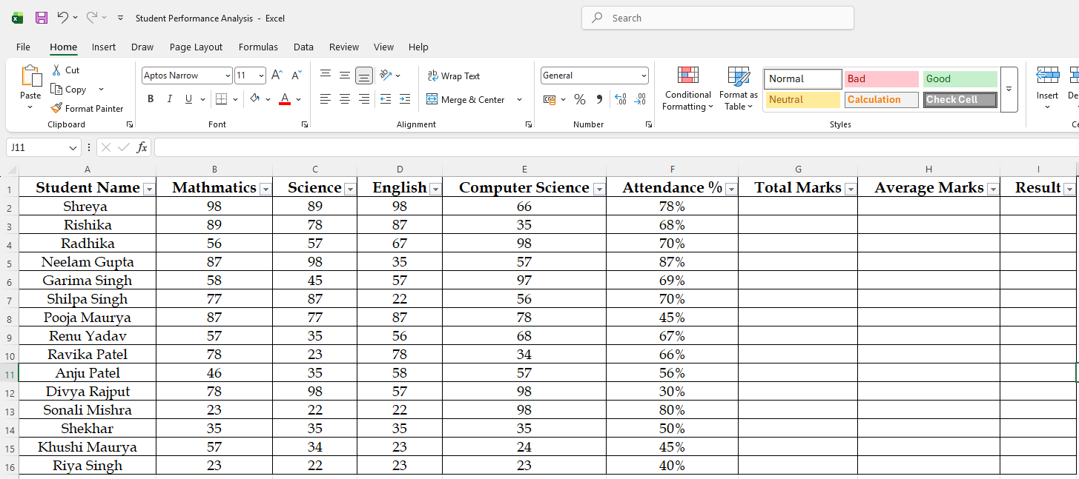

- Applying Formulas
Used formulas to calculate Total Marks, Average Marks and Result.

- Apply Conditional Formatting
Highlighted average above 75 and Failed students.
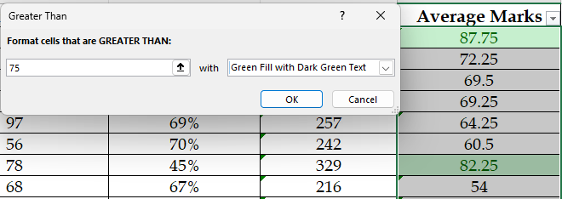
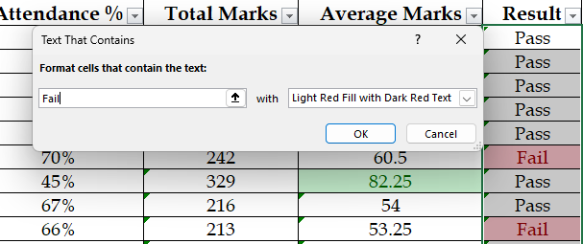

- Sort and Filter Data
Sorted students by Total Marks and applied filters.
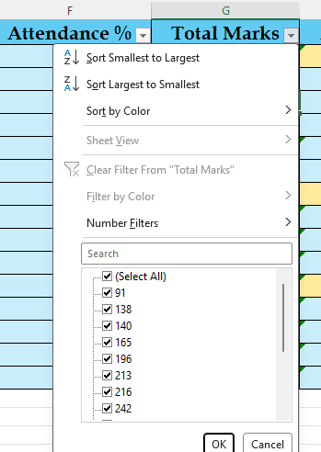

\

- Create Analysis
Calculated Highest Total, Lowest Total and Class Average

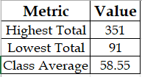

- Create PivotTable and PivotChart
Created a PivotTable and a Column PivotChart to analyze student total marks.
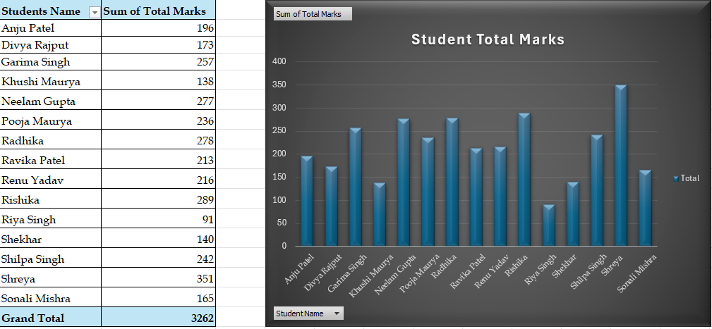

- Save the Workbook
Saved the completed workbook in Microsoft Excel format (.xlsx).
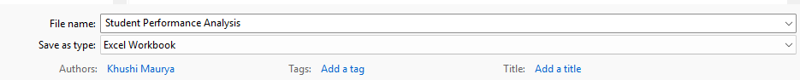

- Result: Student Performance was successfully analyzed using Microsoft Excel.

